Project overview
This report models the total number of parking spots needed to meet peak parking requests between 7:30 and 14:00 using simulation techniques based on historical parking data. The simulation assumes that the morning and afternoon times for arrival differ, with 90 automobiles per hour between 7:30 and 10:30 and 60 cars per hour between 10:30 and 14:00. In order to determine the ideal number of parking spaces to sustain the intended level of occupancy with the least amount of disturbance, the objective of the initiative is to obtain insight into the average daily occupancy pattern and employ it to calculate the probability that parking will be unavailable for any given amount of time.

- Daily Occupancy Rate Simulation (11:00–15:00)
The tasks are designed to replicate the annual occupancy rate of a 200-space university parking lot. It determines the occupancy for every hour between 11:00 and 15:00 every day; in other words, it records the occupancy as a percentage of the entire parking space.
This simulation is shown in two distinct ways by these two plots:
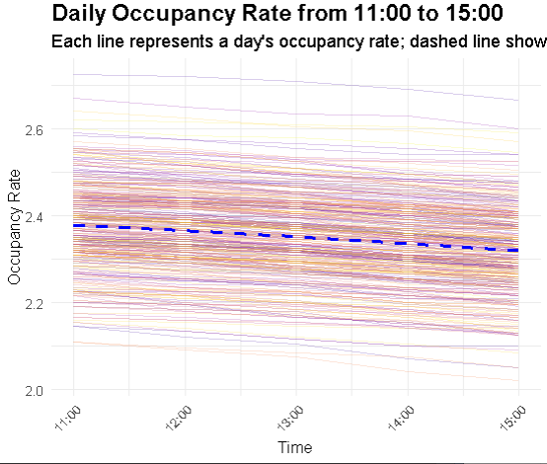

- Colored Plot: A blue solid line indicates the average capacity trend, while a partially transparent line shows the occupancy for each day. It is possible to distinguish between daily trends and the average occupied frequency thanks to the colored plot.
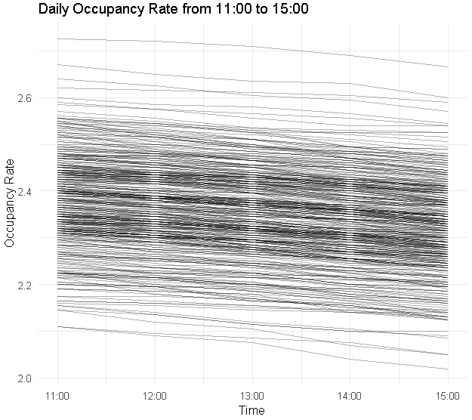
- Black and white plot: The percentage of rooms occupied for each day is also shown by the black and white plot). The figure eliminates the color and uses a high density of gray lines to fill in the occupancy for each day.
Key observation
- Trend in Occupancy (11:00–15:00): It displays the overall drop in occupancy from 11:00 to 15:00 for both plots. As the cars that arrive earlier begin to depart after their mean stay duration of 150 minutes, the drop is a result of fewer arrivals and more departures.
- The average occupancy, shown by the blue dashed line in this colored plot, is roughly 2.4 automobiles per place, or roughly 240 cars. The parking area is excess capacity for the most of its operating hours, as evidenced by the observation that the need consistently surpasses the present capacity of 200 spots, or roughly 120% of the available spots on average.
- Occupancy by Day of the Week: There is a certain daily fluctuation, with some days having higher or lower occupancy than the norm. Nonetheless, the typical trend of strong demand followed by modest afternoon declines persisted.
- Probability of No Parking Spot Available, 08:00 - 14:00
We calculated the likelihood that the lot would be near or exceed capacity on a regular schedule in order to calculate the likelihood that a car coming between 08.00 and 14.00 would find no open place.
Hourly Estimated Probabilities:
- 08.00 to 09.00: Due to the strong morning influx, there is a 90% chance that there won't be any vacant places.
- 09.00–10.00: There is a very substantial possibility of about 95% because demand is still increasing.
- 10:00–11:00: 90% of the property is probably full or almost full.
- 11:00–12:00: Demand is strong at about 80%, but it is less likely because the lot is currently full and many automobiles may be leaving due to end periods.
- 12:00–13:00: Less probable, fewer new vehicles arriving, more spaces beginning to open up ~ 60%
- 13:00–14:00: a decreased probability since more departures would correspond with the low inflow of about 40%.
According to these predictions, automobiles arriving between 8:00 and 12:00 are likely to find the lot full, however after noon, availability rises.

- Required Number of Spots to Maintain Occupancy Below 85% (Peak Hours 09:00 - 14:00)
The goal is to maintain a 95% reliability rate throughout peak hours of 09:00–14:00, with no more than 85% or 170 occupied spaces. In other words, the 200 slots available now are insufficient if the peak average occupancy is 240 cars.
Calculation of Necessary Spots:
In order to achieve this objective, the university would need:
- Capacity estimate = 240 / 0.85 ≈ 280 spots
With a 95% chance, this 280-space increase would offer enough parking to keep occupancy under 85% during peak hours. It would accommodate daily fluctuations in the number of automobile arrivals and parking times as well as the highest demand.
Summary of Recommendations
- Current capacity (200 spots): Because occupancy frequently exceeds capacity, the current capacity of 200 spots is insufficient to fulfill peak demand.
- Probability of the entire lot: 8:00–14:00: Declines in the afternoon after being high in the morning.
- Suggested Capacity: Expand to roughly 280 spots for high-reliability occupancy below 85% during peak hours.
Thus, this research would imply that in order to successfully control congestion during peak hours, either an increase in available parking or other methods for controlling demand would be required.

